Diviners Set Design Worksheet Name: ____________________________________Class Period: _____
Scene Name and description: ____________________________________________________________________________________________________________________________________________________________________________________________________
Characters in the Scene: ______________________________________________________________________________
Time of Day: ____________________ Season: ______________________
How will the Actors interact with the set? ____________________________________________________________________________________________________________________________________________________________________________________________________
Explain: How does the set express the following -
The Mood and Spirit of the Play? (What things are included in your design that show the mood/spirit) ____________________________________________________________________________________________________________________________________________________________________________________________________
The Historical Period of the Play? (how do the set & set pieces help us understand the time period?) ____________________________________________________________________________________________________________________________________________________________________________________________________
The Locale (place) of the Play: (how do the set & set pieces help us understand where this is taking place?) ____________________________________________________________________________________________________________________________________________________________________________________________________
The Socioeconomic status and personality of the characters? (what things are included to show the wealth/class?) ____________________________________________________________________________________________________________________________________________________________________________________________________
The Season of the year? (what details are included to show what season it is?) ____________________________________________________________________________________________________________________________________________________________________________________________________
You will turn in one design. It should be a colored design from the view of the audience.
Your final design should have:
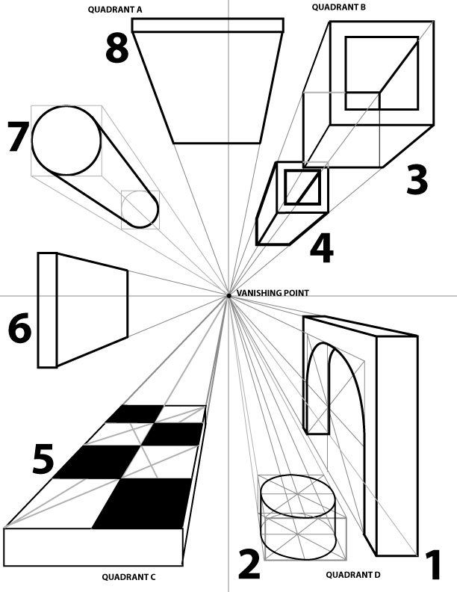
- the title of the play
- the scene
- your signature
- color on furniture, walls and floor
- perspective

